**Week 5: What has been done**

**The front end of the app:**

The front end of the app has largely been completed bar maybe one or two changes that we may need to make along the way. However, this is essentially the end design

**Updated Nav bar:**

The navbar has been updated with the new pages that have been added and their URLs



**Submit a Review Page:**

The submit a review page design is completed and ready for the back-end design

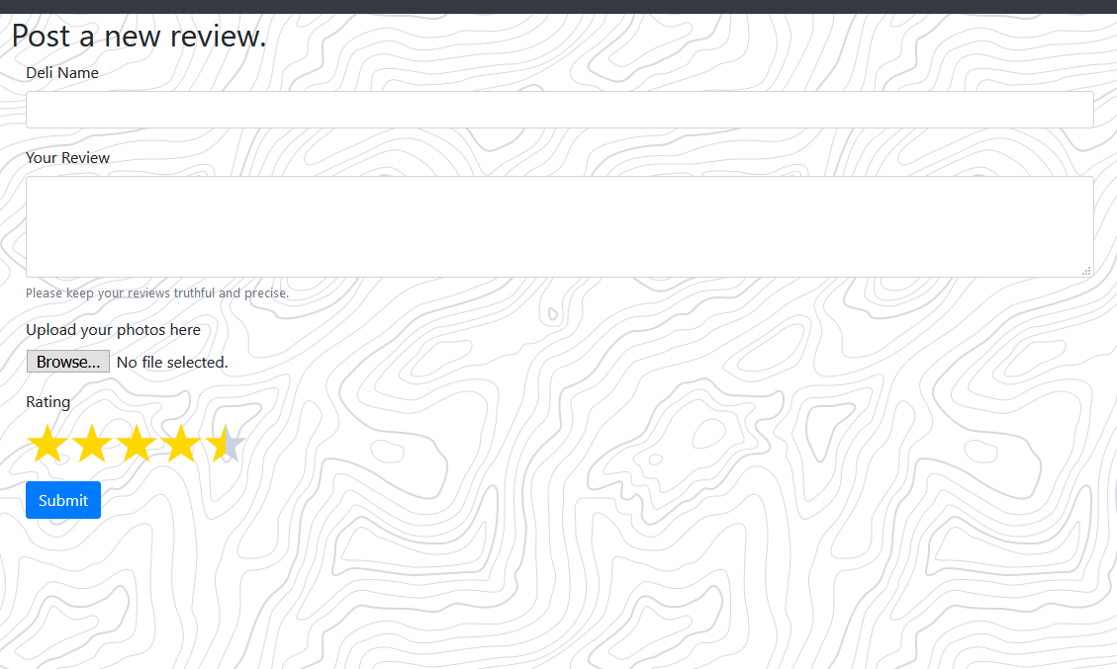

**Map / Locator page:**

The map page has been implemented and is ready for the back-end implementation

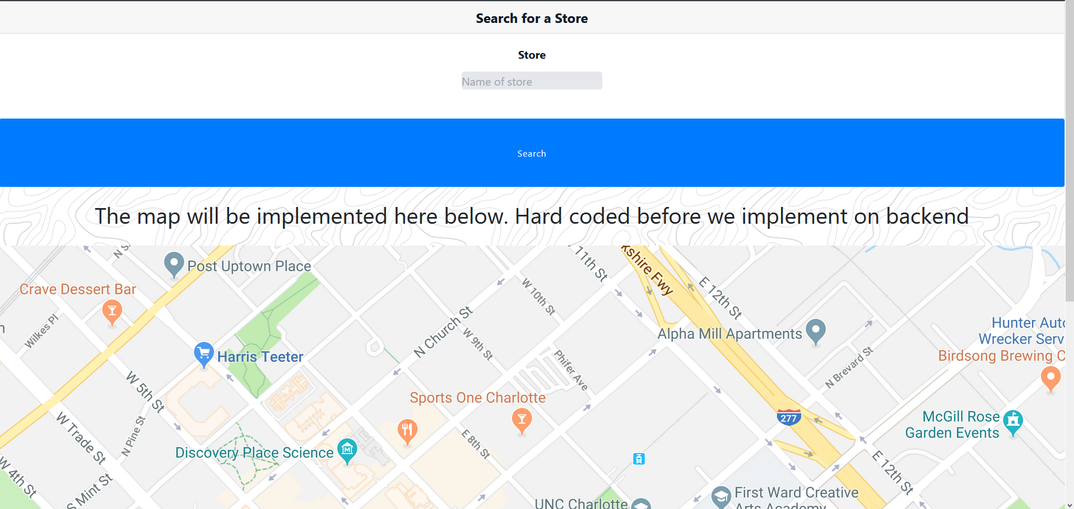

**Updated Card on home page:**

Card on the home page has been updated to include the star ratings.

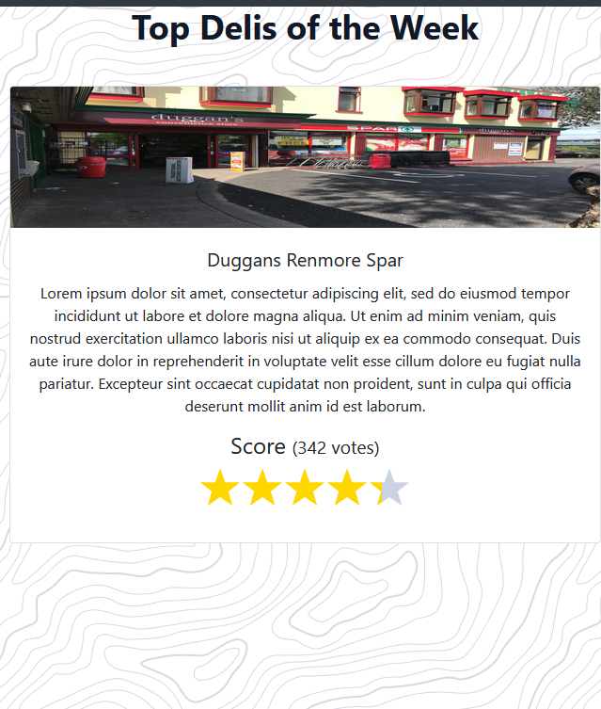

***For this week we plan to design a database and create said database.***